Offline LCA queries

tree $T$ with $n$ nodes, $m$ queries of the form $(u, v)$, for each query find the LCA of vertices $u$ and $v$

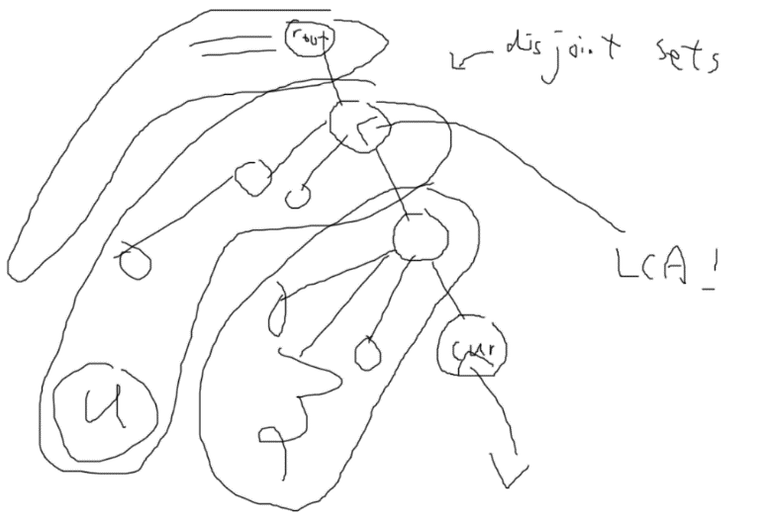

We are currently at $v$. LCA of $u$ and $v$ is either $v$ or its ancestor. For a fixed $v$ the visited nodes of the tree split into a set of disjoint sets, where each ancestor of $v$ has its own set containing itself and children who are not part of the path from $v$ to the root. The root of the set containing $u$ is the LCA of $u$ and $v$.

The algorithm answers all queries with 1 DFS, and answers a query $(u, v)$ at node $v$ if $u$ is visited.

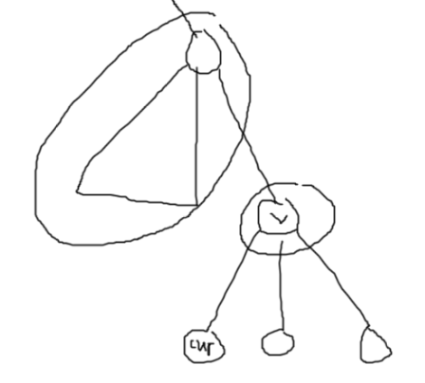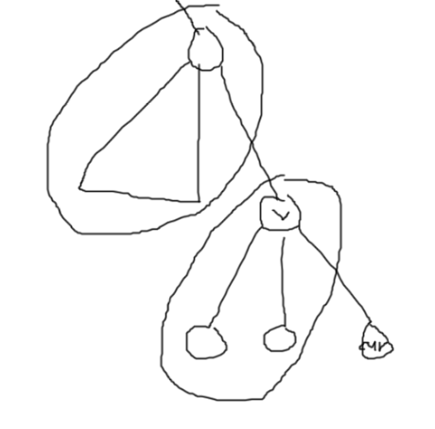How to maintain the sets? disjoint set union! Let’s say we are at $v$. We make a new set with only $v$ in it, then recursion to the children. After that, add the set of the children to the set of $v$.

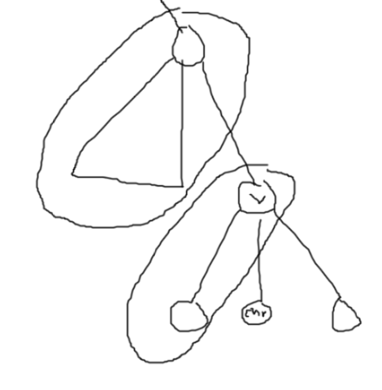

After adding all the sets of the children, answer the queries.

Why does this work? Won’t some queries be missed due to the parent’s set being incomplete? No! Because if it was incomplete, the query can be answered later when we are processing the other node!

<https://cp-algorithms.com/graph/lca_tarjan.html>